Register for IBM Cloud

|  |  |
| --- | --- |
| **Team ID** | **IBM-Project-29170-1660121813** |
| **Project Name** | **Emerging Method For Early Detection Of Forest Fire.** |

# 

# AIM

To register for cloud.

# STEPS

Login to IBM Cloud with smart interns mail ID and Password.





1. Select the IBM cloud.

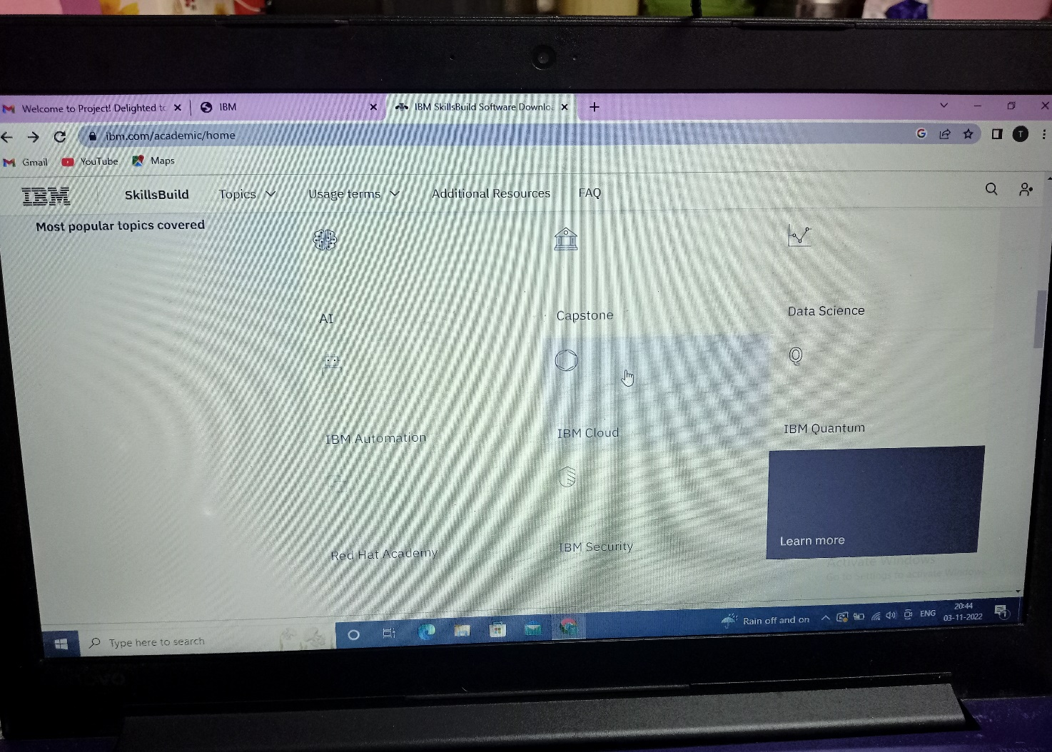

3.Select the Software.

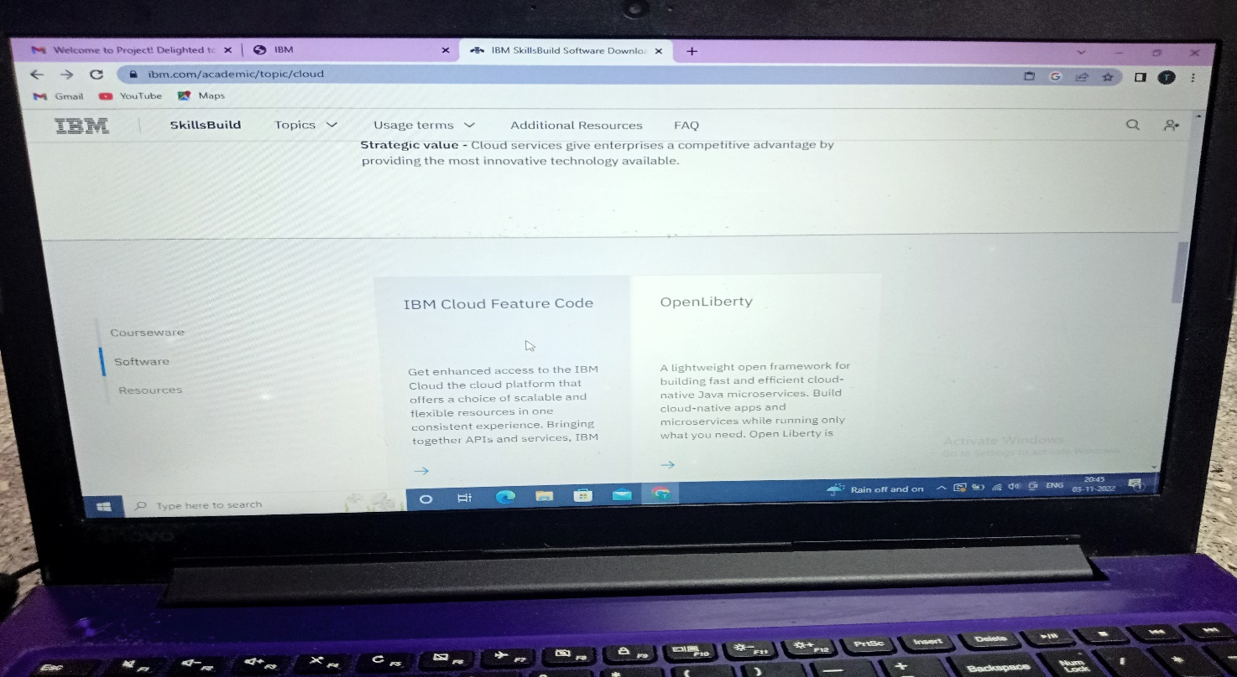

4.Our cloud has been created.

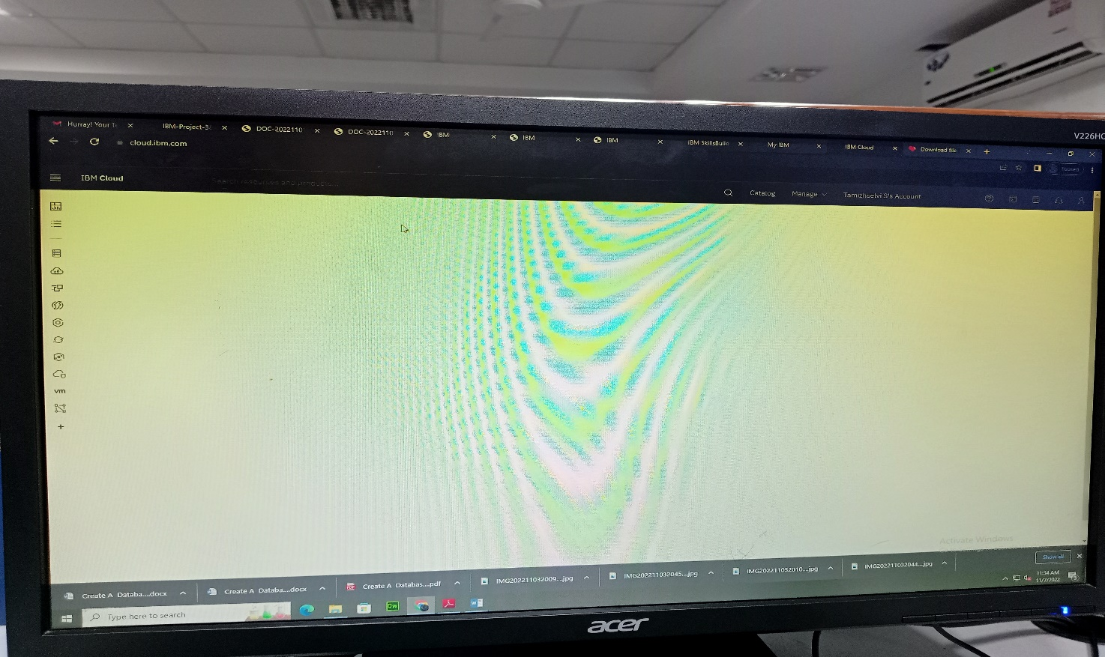

# RESULT:

A database to store the location data on Cloud Database has been created

successful.